**North South University**



**Department of ELECTRICAL AND COMPUTER SCIENCE**

**PROJECT SPECIFICATION AND DESIGN**

**COURSE: CSE-499-B**

**SECTION-12**

**GROUP-1**

PROJECT TITLE: GARBAGE COLLECTOR ROBOT

Supervised BY: Dr. Shazzad Hosain

**SUBMITTED BY-**

|  |  |
| --- | --- |
| **NAME** | **ID** |
| **FARJANA ALAM** | **1620060042** |
| **MOIN SHAHRIYAR** | **1610586042** |
| **SARHAN OSMAN BHUIYA** | **1611008042** |

**INTRODUCTION**

We are presenting a smart robot that could present a viable solution towards efficient waste management which is based on embedded, digital image processing. The system is designed so that it can automatically detect and collect the garbage. This proposal report describes the basic idea of detection and collection. The detection is done by using the image processing algorithm and the collection of garbage is done by the robot. The video taken by the Pi camera will be processed by the Raspberry Pi. For each frame taken, Raspberry Pi will detect any garbage present in the frame and send signals to the robot. Our robot will calculate its position, calibrate the motors according to the position of the garbage so that it will go to the acquired position and collect the garbage. The collected garbage will be categorized as Paper, Plastic, Metal and Glass and kept in different parts of a basket.

**IDEA AND PROBLEM STATEMENT**

Bangladesh is the ninth most populous and twelfth most densely populated country in the world. With this population growth, there is an increasing problem of waste management particularly in the larger cities. Currently, according to an UNFPA report, Dhaka is one of the most polluted cities in the world and one of the issues concerned is the management of municipal waste. Current (2019) waste generation in Bangladesh is around 22.4 million tons per year or 150 kg/cap/year.[1] There is an increasing rate of waste generation in Bangladesh and it is projected to reach 47,064 tons per day by 2025. The rate of waste generation is expected to increase to 220 kg/cap/year in 2025. A significant percentage of the population has zero access to proper waste disposal services, which will in effect lead to the problem of waste mismanagement. The total waste collection rate in major cities of Bangladesh such as Dhaka is only 37%. When waste is not properly collected, it will be illegally disposed of and this will pose serious environmental and health hazards to the Bangladeshis. [2]

One of the most adverse impacts of poor waste management, especially municipal waste, is the incidence and prevalence of diseases such as malaria and respiratory problems, as well as other illnesses through the contamination of ground water. Biomedical wastes pose great danger in Bangladesh too as a report estimated that 20% of the biomedical waste is "highly infectious" and is a hazard since it is often disposed of into the sewage system or drains.[3] With regards to the living standards, solid waste leads to blockage in the drainage system which leads to flooding in the streets. Consequently, mosquitoes and bad odor are among the negative impacts resulted. [4] The main objective of this project is to recognize and categorize the waste autonomously, which require minimal human intervention. The robot will collect waste categorizing them as Plastic, Paper, Glass and Metal and put them in a container.

**SPECIFICATION**

The proposed system concentrates on identification, classification, segregation and collection of waste. The waste, which is in unsorted manner, is dumped in a landfill, which further creates hazardous health problems. The proposed system aims to recognize and categorize the waste autonomously, which require minimal human intervention. This entire process of recognition of waste material is based on the detection of the objects.

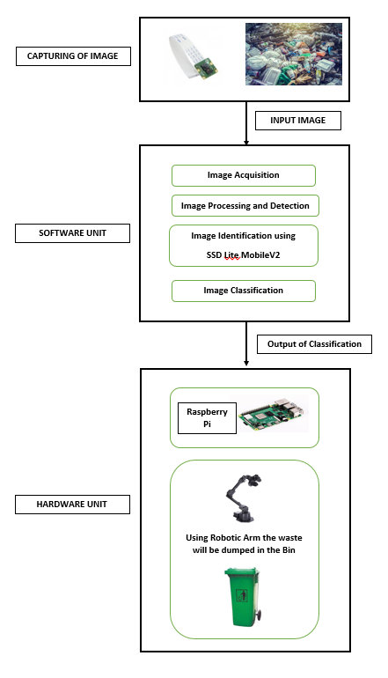

Fig: Process of Garbage Collection

**DETECTION**

The system will be trained through datasets by using machine learning technique such as SINGLE SHOT DETECTION (SSD). Utilizing Raspberry Pi the characterization result will be given to the equipment part of the framework with the goal that it will be dumped in its separate containers. The robot will collect waste and automatically categorizing them as Plastic, Paper, Glass and Metal. As the system works independently, there is no need of human mediation to control.

**COLLECTION**

For the collection part, the robot will at first go in front of the garbage and with the help of sonar sensors will calculate the exact distance between the garbage and the robot. Later it will send the data to the Arduino which will decide if it is possible to collect the garbage or not within that calculated distance. If it is possible, Arduino will send a signal to the robotic arm to grab the waste in front of it. Once the garbage is collected, it will drop the garbage in a basket which will be divided into 4 parts (Paper/Plastic/Metal/Glass). The basket will be rotating based on which type of garbage has been collected. So, if paper is collected the basket will rotate to the side of the paper and the robotic arm will drop the paper in the specific paper part of the basket.

**USECASE / SUBSYSTEM**

There are basically two use case for this project. One of them is autonomous and the other is human control.

**USECASE-1 (AUTONOMOUS)**

Here the Garbage Collector Robot will be a driverless autonomous vehicle specifically designed to collect waste which require no human intervention. It will automatically detect the waste and go towards the waste and grab the waste with its robotic arm. Once the waste is collected, it will automatically drop the waste in its specified (Paper/Plastic/Metal/Glass) container.

**USECASE-2 (HUMAN CONTROL)**

Here the Garbage Collector Robot can be controlled manually by a human with the help of an app. The robot can be manually sent front, back, right and left using button controls on the app and can also pickup any waste from the ground using the robotic arm.

**SYSTEM DESIGN / ARCHITECTURE**

The robot is basically of 4 main parts. At first for the software i.e. the detection part, we used Raspberry Pi and Pi Camera which was trained to detect wastes like Paper, Plastic, Metal and Glass. Next, for the movement of the robot we used 4WD robot vehicle that allows the robot to move in any direction it wants to. Thirdly, we attached a Robotic Arm to the vehicle which gradually grabs the garbage it detects. Finally, the robot has a rotating bin/basket behind it which collects the garbage grabbed by the robotic arm. So, if paper is collected the basket will rotate to the side of the paper and the robotic arm will drop the paper in the specific paper part of the basket.

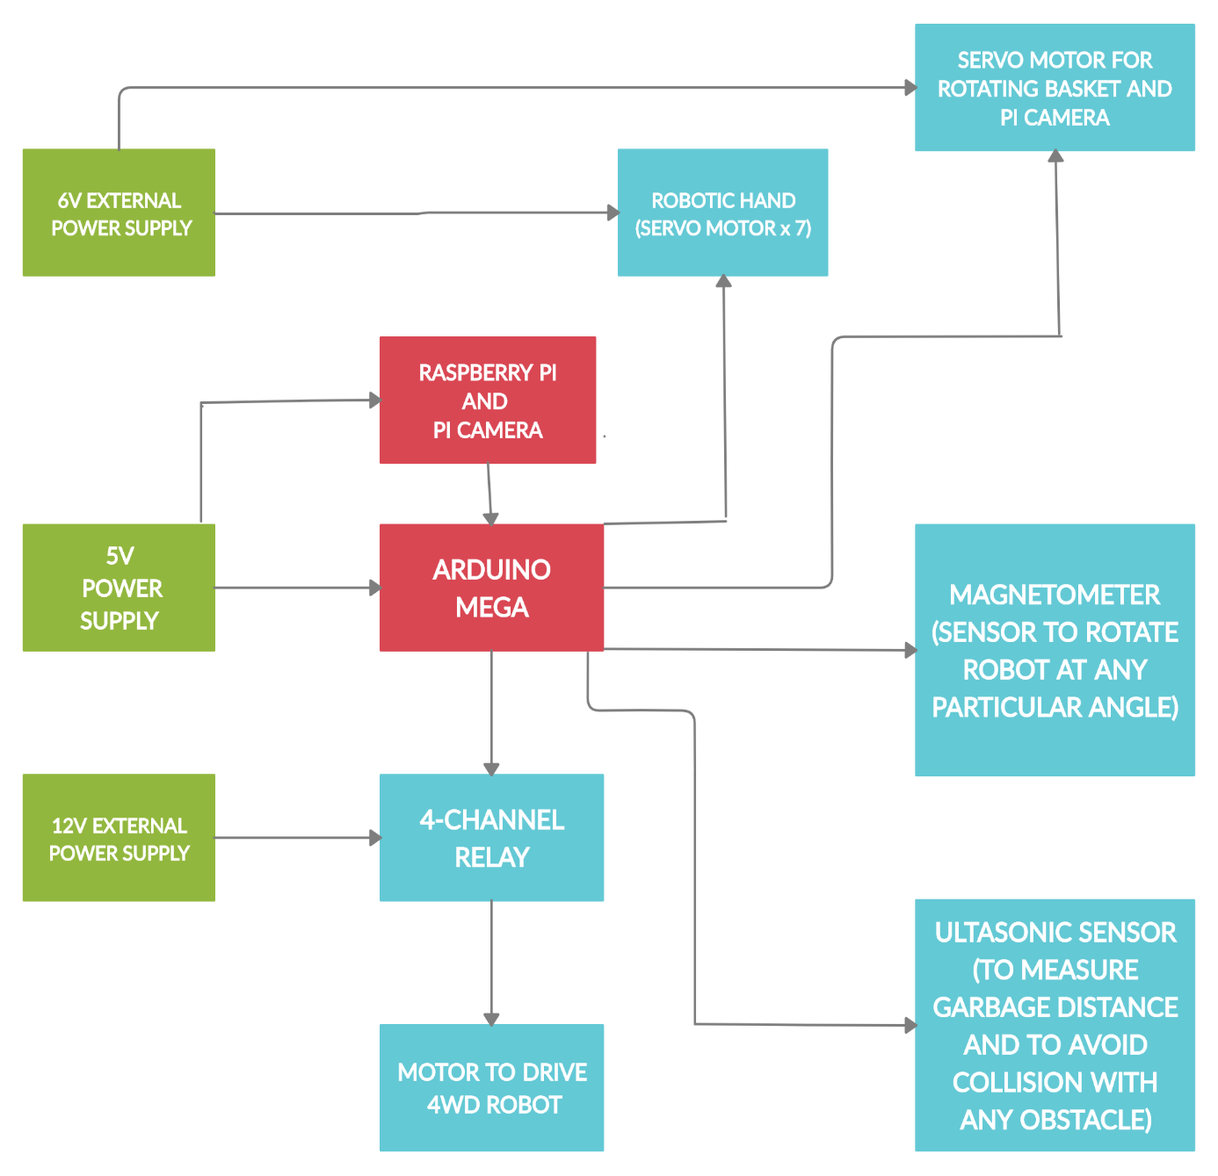

Fig: Architecture of Garbage Collection Robot

**COMPONENT LIST**

The table below comprises of the major components required to build our robot. The component and its quantity might change later as required for the project.

|  |  |  |
| --- | --- | --- |
| NUMBER | COMPONENTS | QUANTITY |
| 1 | Customized Metallic Robot Body | 1 |
| 2 | Toyota Denso Motor | 4 |
| 3 | 12V 7.5 AH Power Supply | 1 |
| 4 | 4-Channel Relay | 2 |
| 5 | Arduino Mega | 1 |
| 6 | Node MCU | 1 |
| 7 | Robotic Hand 6DOF | 1 |
| 8 | Mg996R Servo | 8 |
| 9 | Metal Horn | 8 |
| 10 | 5G90S Servo | 1 |
| 11 | 6V 4.5 AH Power Supply | 1 |
| 12 | Sonar Sensor | 3 |
| 13 | Wheel 4 Inch | 4 |
| 14 | Raspberry Pi with 5MP Camera | 1 |
| 15 | Custom Plate to carry two servo in shoulder | 1 |
| 16 | Bread Board | 1 |
| 17 | 5V Power Supply | 1 |
| 18 | Multi-Functional Bracket | 1 |
| 19 | Basket | 1 |
| 20 | Wires | (as required) |

**CLASS DIAGRAM WITH UML**

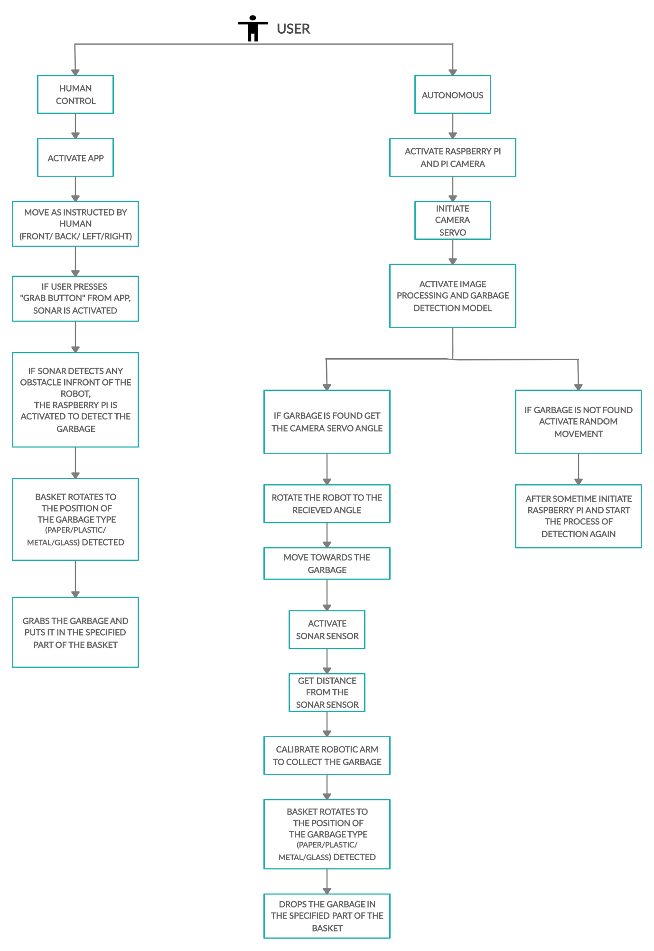

**ANALYSIS AND DESIGN TOOLS USED**

**Arduino IDE**

The Arduino integrated development environment (IDE) is a cross-platform application (for Windows, macOS, Linux) that is written in the programming language Java. It is used to write and upload programs to Arduino compatible boards, but also, with the help of 3rd party cores, other vendor development boards.

The source code for the IDE is released under the GNU General Public License, version 2. The Arduino IDE supports the languages C and C++ using special rules of code structuring. The Arduino IDE supplies a software library from the Wiring project, which provides many common input and output procedures. User-written code only requires two basic functions, for starting the sketch and the main program loop, that are compiled and linked with a program stub main() into an executable cyclic executive program with the GNU toolchain, also included with the IDE distribution. The Arduino IDE employs the program avrdude to convert the executable code into a text file in hexadecimal encoding that is loaded into the Arduino board by a loader program in the board's firmware.

**REFERENCES**

1. <http://www.atlas.d-waste.com/>
2. <http://wasteconcern.org/Publication/Waste%20Survey_05.pdf>
3. <http://www.apo-tokyo.org/publications/files/ind-22-swm.pdf>
4. <https://www.daily-sun.com/printversion/details/346071/2018/10/28/Waste-Management-in-Bangladesh>
5. <http://www.ijfcc.org/papers/329-CS3004.pdf>
6. <http://www.citylab.com/tech/2016/03/the-robot-garbage-collectors-are-coming/471429/>
7. <http://www.ipcbee.com/vol66/019-IEEA2014-A044.pdf>
8. <https://github.com/tensorflow/models/tree/master/research/object_detection>
9. <https://github.com/topics/object-detection>
10. <https://github.com/bourdakos1/Custom-Object-Detection>
11. <https://www.tensorflow.org/lite/models/object_detection/overview>
12. <https://tensorflow-object-detection-api-tutorial.readthedocs.io/en/latest/training.html>
13. <https://github.com/EdjeElectronics/TensorFlow-Object-Detection-on-the-Raspberry-Pi>
14. <https://www.pyimagesearch.com/2017/10/16/raspberry-pi-deep-learning-object-detection-with-opencv/>